Project Organization

-(package) indi.yuanyuam.proj1.driver : run the project

+ (class) Driver :

Create Automobile by BuildAuto , then test the update method and methods relative to “choice”.

+ (class) TestException:

In this class, I have tested 5 exceptions: file not found, missing base price, missing option set name, missing option price, missing car model name; For “FileNotFound” exception, the program will load a default file. For other “MissingInfomation” exceptions, the program will prompt users to enter the values.

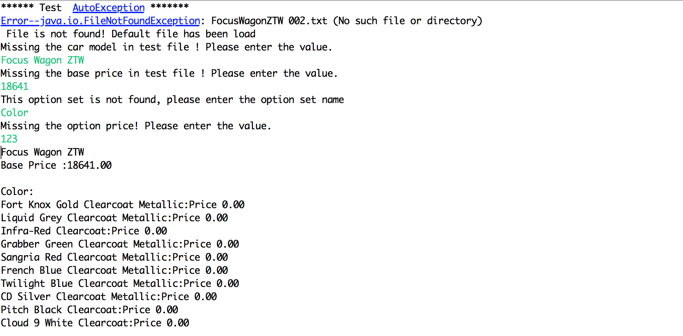

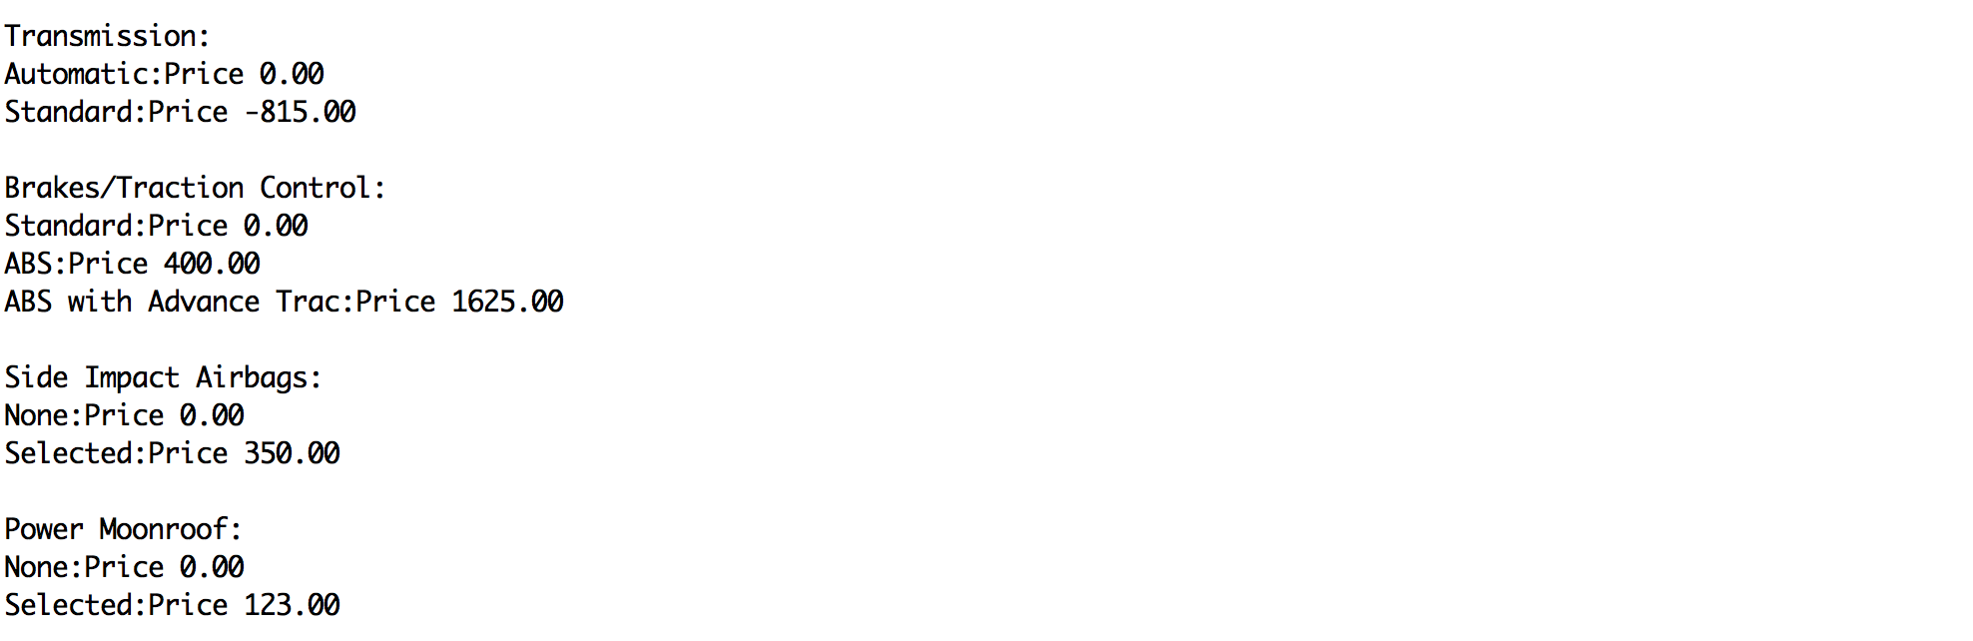

——————————————————————————————————

-(package) indi.yuanyuam.proj1.model : Hold the properties of the car

+ (class) Automobile: hold the car configuration

The methods in this class includes: setters and getters for name, make , model and base price, and print method to print the whole set.

+ (class) OptionSet: option set of car configuration

The class that can hold name of the model, base price and information about all the properties. The methods in this class includes: setters and getters for name and price, update method for name and price, and print method to print the whole set.

In addition, there is the inner class called Option.

+ (inner class) Option: options for each option set

The methods in this class includes: setters and getters for name, make , model and base price, and print method to print the whole set.

——————————————————————————————————

-(package) indi.yuanyuam.proj1.test: all the test classes

+ (class) TestAutomobileOption: test the methods defined in Automobile class which are relative to option operation.

+ (class) TestAutomobileOptionSet: test the methods defined in Automobile class which are relative to option set operation.

——————————————————————————————————

- (package) indi.yuanyuam.proj1.util: package for Until

+ (class) Util: built the Automobile object, serialize and deserialize the object

The methods in this class includes the method readFile to built the Automobile object. Method serializeAuto is used for serializing Automobile object while method derializeAuto is used for deserializing Automobile object.

——————————————————————————————————

- (package) indi.yuanyuam.proj1.adapter

+ (interface) CreateAuto:

Include two methods: buildAuto and printAuto;

+(interface) UpdateAuto:

Include two methods: update the option set name and price

+(interface) FixAuto

Include the method: fixAuto

+(class) BuildAuto

This class extends ProxyAutomobile, implement CreateAuto, FixAuto, and UpdateAutoi interfaces.

+(extract class) ProxyAutomobile

* This  class contains all the implementation of any method declared in the interface.

——————————————————————————————————

- (package) indi.yuanyuam.project.exception

+ (class):ExceptionEnum

This is an enum class for enumeration all exceptions

+ (class): AutoException

+ (class): Helper

Includes the method fixing all exception listed in CustomExceptionEnum.

Ps. All the methods in class “OptionSet” and “Option” are protected and variables in class “Automobile”, OptionSet” and “Option” are private. Other class can not access the optionset and option directly ( must access them by Automobile class).